- Exceed/System changes;
  - MTV set up
    - In CODELKUP, LISTNAME = “MTV”, Code will be MTV code.
      - DP : Datapulse,
      - ML : Moduslink,
      - IPS : IPS (will route to ML),
      - SCH : Schenker.
    - Total of two MTVs that take over order portion so far.

  - SKU set up
    - Microsoft needs to provide us with the sku set up. This set up will indicate which SKU below to which MTV. Field busr4 in SKU table will be the MTV indicator.
    - Screen “SKU Maintenance” need to include field busr4 for ops to update which MTV that the SKU belong to. Highlight color in reb in SKU maintenance screen if no busr4 define for that SKU.
    - One time upload program to help ops for one time set up of busr4 before live.

  - Location setup
    - ML for Moduslink
    - DP for Datapulse

  - Folder set up in server
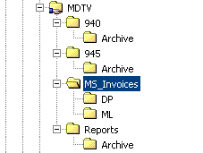

  - 940 filtering logic for Schenker to post 940 H & D files to MTV
    - When Schenker receive 940 header and detail files from Microsoft via our US gateway, beside upload into WMS, currently already upload, below logic will be built to filter and post 940 header and detail text files to MTV. Post 940 text file to MTV folder, see ftp info below.

    - E-mail with 940 text file will send out as well.
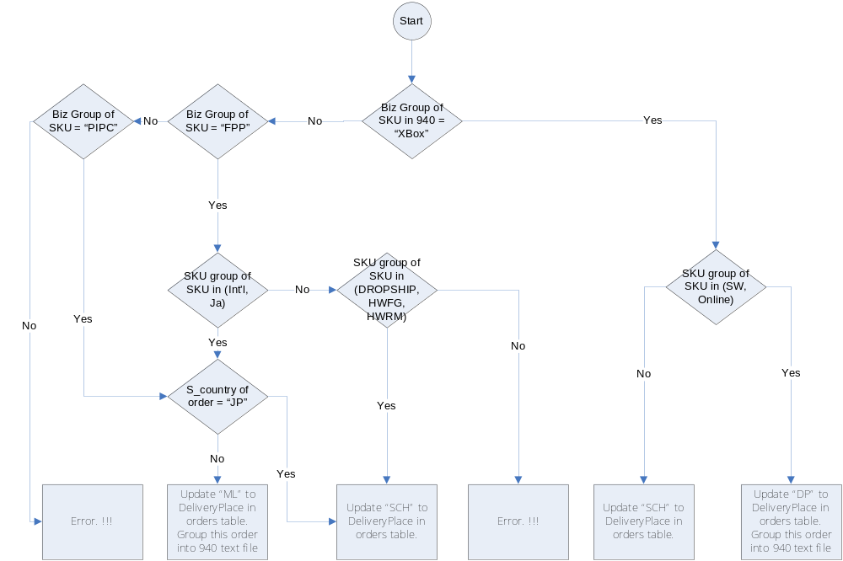

    - Also : Need to show DeliveryPlace on Batch allocation screen.
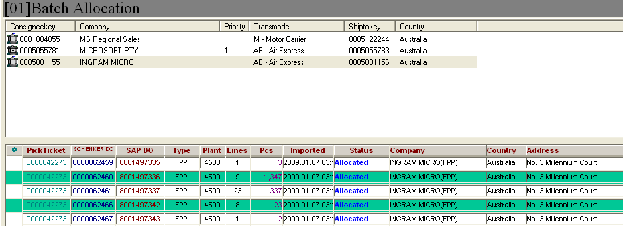

  - MS Invoices posting routing logic in Schenker
    - MS invoice name is with DL#+Inv# (e.g. DL8001496983_IN9080766446.PSC).
    - Use the DL# (8001496983) in the file name to check on the orders table using externorderkey.
    - Refer to the DeliveryPlace in orders table to route the invoice to below ftp server;
      - DP ➔ Datapluse ftp server in folder “MS_Invocies”.
      - ML ➔ Moduslink ftp server in folder “MS_Invocies”.

  - 945 handling from MTV to Microsoft.
    - MTV’s system will generate 945 based on the template given and post to MTV folder (Schenker\945).
    - Note : All the 945 from MTV is for 100% order detail fulfillment.
    - Schenker system will pick up the 945 from MTV ftp server and import information into Exceed.
    - Auto allocation and pick in WMS.
    - For all orders, ops need to go to WMS to release.

  - Shipout/Shipwave
    - Enhance the screen in WMS to allow ops to check all orders for shipwave.
  - Inventory Report.
    - Daily Inventory report continue to post to Microsoft extranet. (Add in MTV, DeliveryPlace in orders table, in the report)
    - Additional request: to post MTV inventory report to MTV ftp server. Use SKU master set up field busr4 as the MTV for grouping of the inventory.
    - Refer to attached file for sample of inventory report (Inventory Summary (2008.12.09).xls).
  - Inbound-Virtual Receipt
    - Highlight the line if Bizgroup or sku group not setup.
    - If Bizgroup or sku group not setup; receiving is not allow.
    - Untag lottable01.
    - Add ‘Received all’ button, which system will assign LP, location.
    - LP will have convention –YYMMDDHHMM
  - Report – Customer status report
    - Add column MTV before invoice.

2. Exceed/System changes;

2.1 Workshop 5 Dec 2008.
2.2 IT development 5-23 Jan 2009.
2.3 MTV provide ftp server info 2 Jan 2009 or before.
2.4 UAT with MTV 19 Jan 2009.
2.5 End to End testing (MS, MTV and Schenker) 2 - 6 Feb 2009.
2.6 Review and decision to live 13 Feb 2009.
2.7 Go live prepare 16 - 20 Feb 2009.
2.8 Go live 23 Feb 2009.

3. Ftp info;
Moduslink contact person : Koh, EngBakEB [engbakeb_koh@moduslink.com]
External User
LoginID : msdtv-ext
Password : Me@moduslink
FTP server : magic.moduslink.com

Datapulse contact person : Kenny [kenny-tan@datapulse.com.sg]
User ID: schenker
Password: kpsc$$78
ftp server : ftp1.datapulse.com.sg or ftp://203.125.142.165

